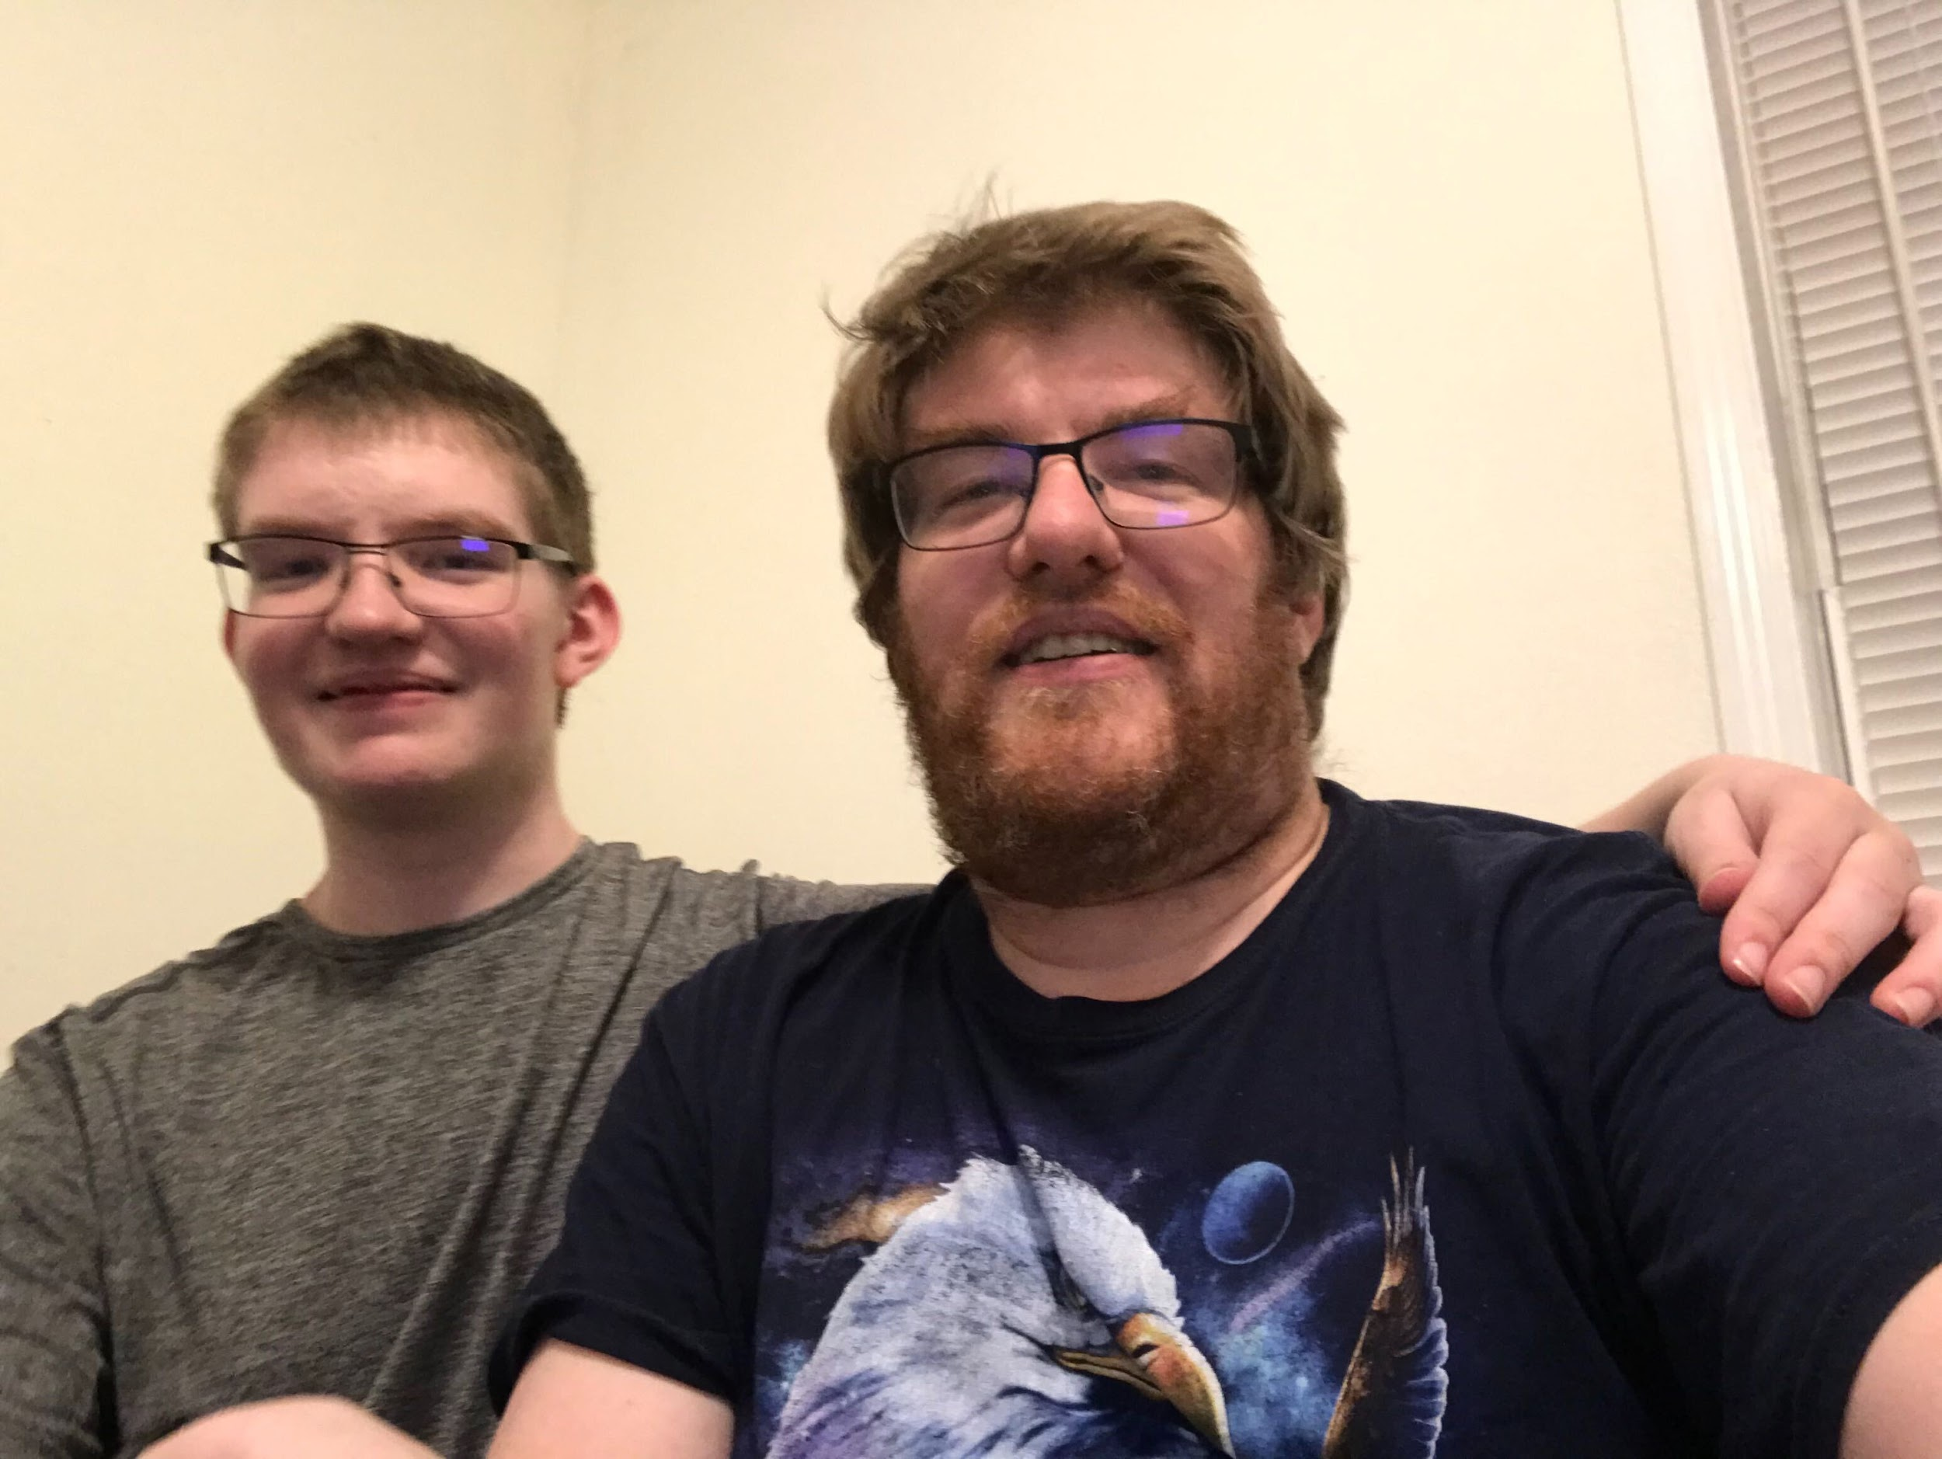

The end of August marked a lot of change in our lives, especially where Josh is concerned. On Monday, both Josh and Elijah started the new school year.

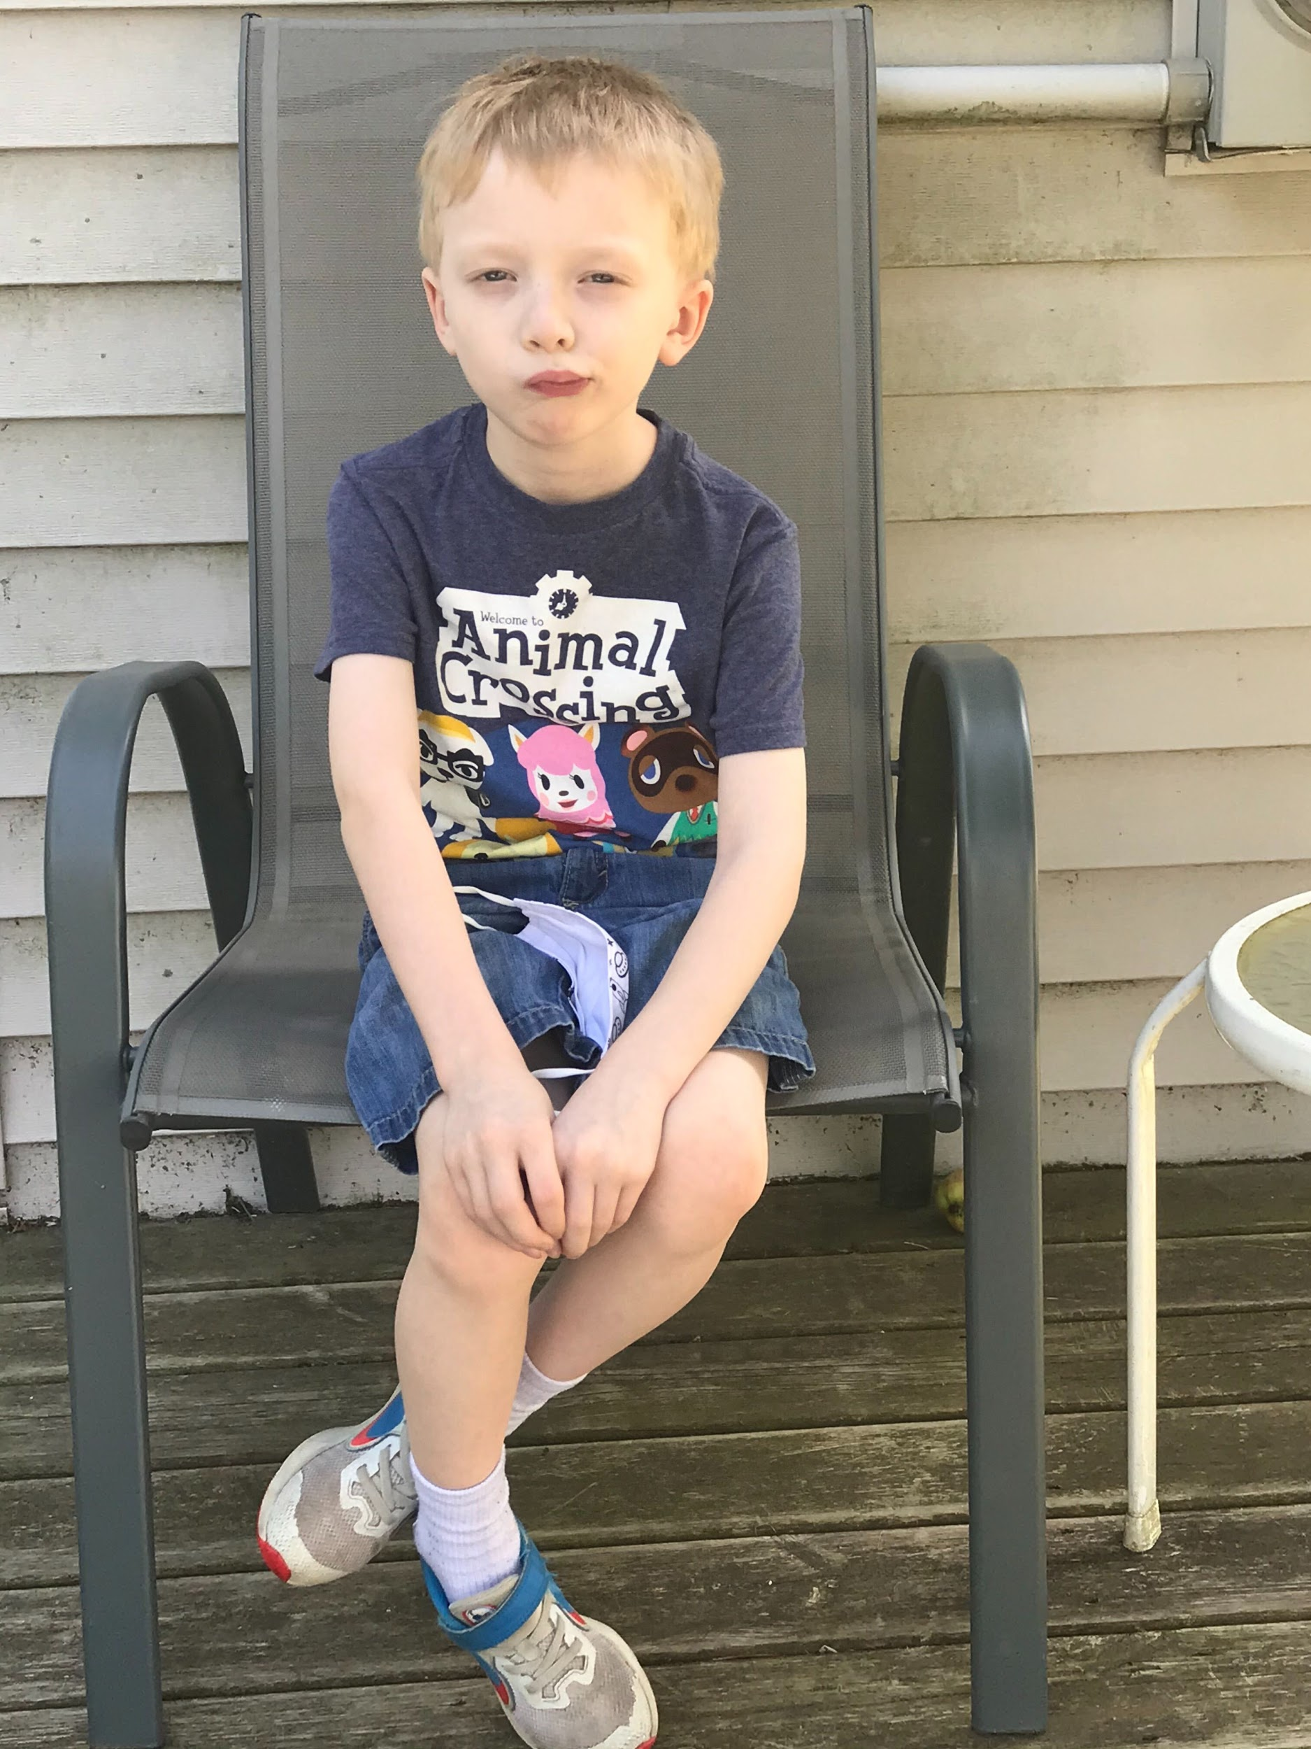

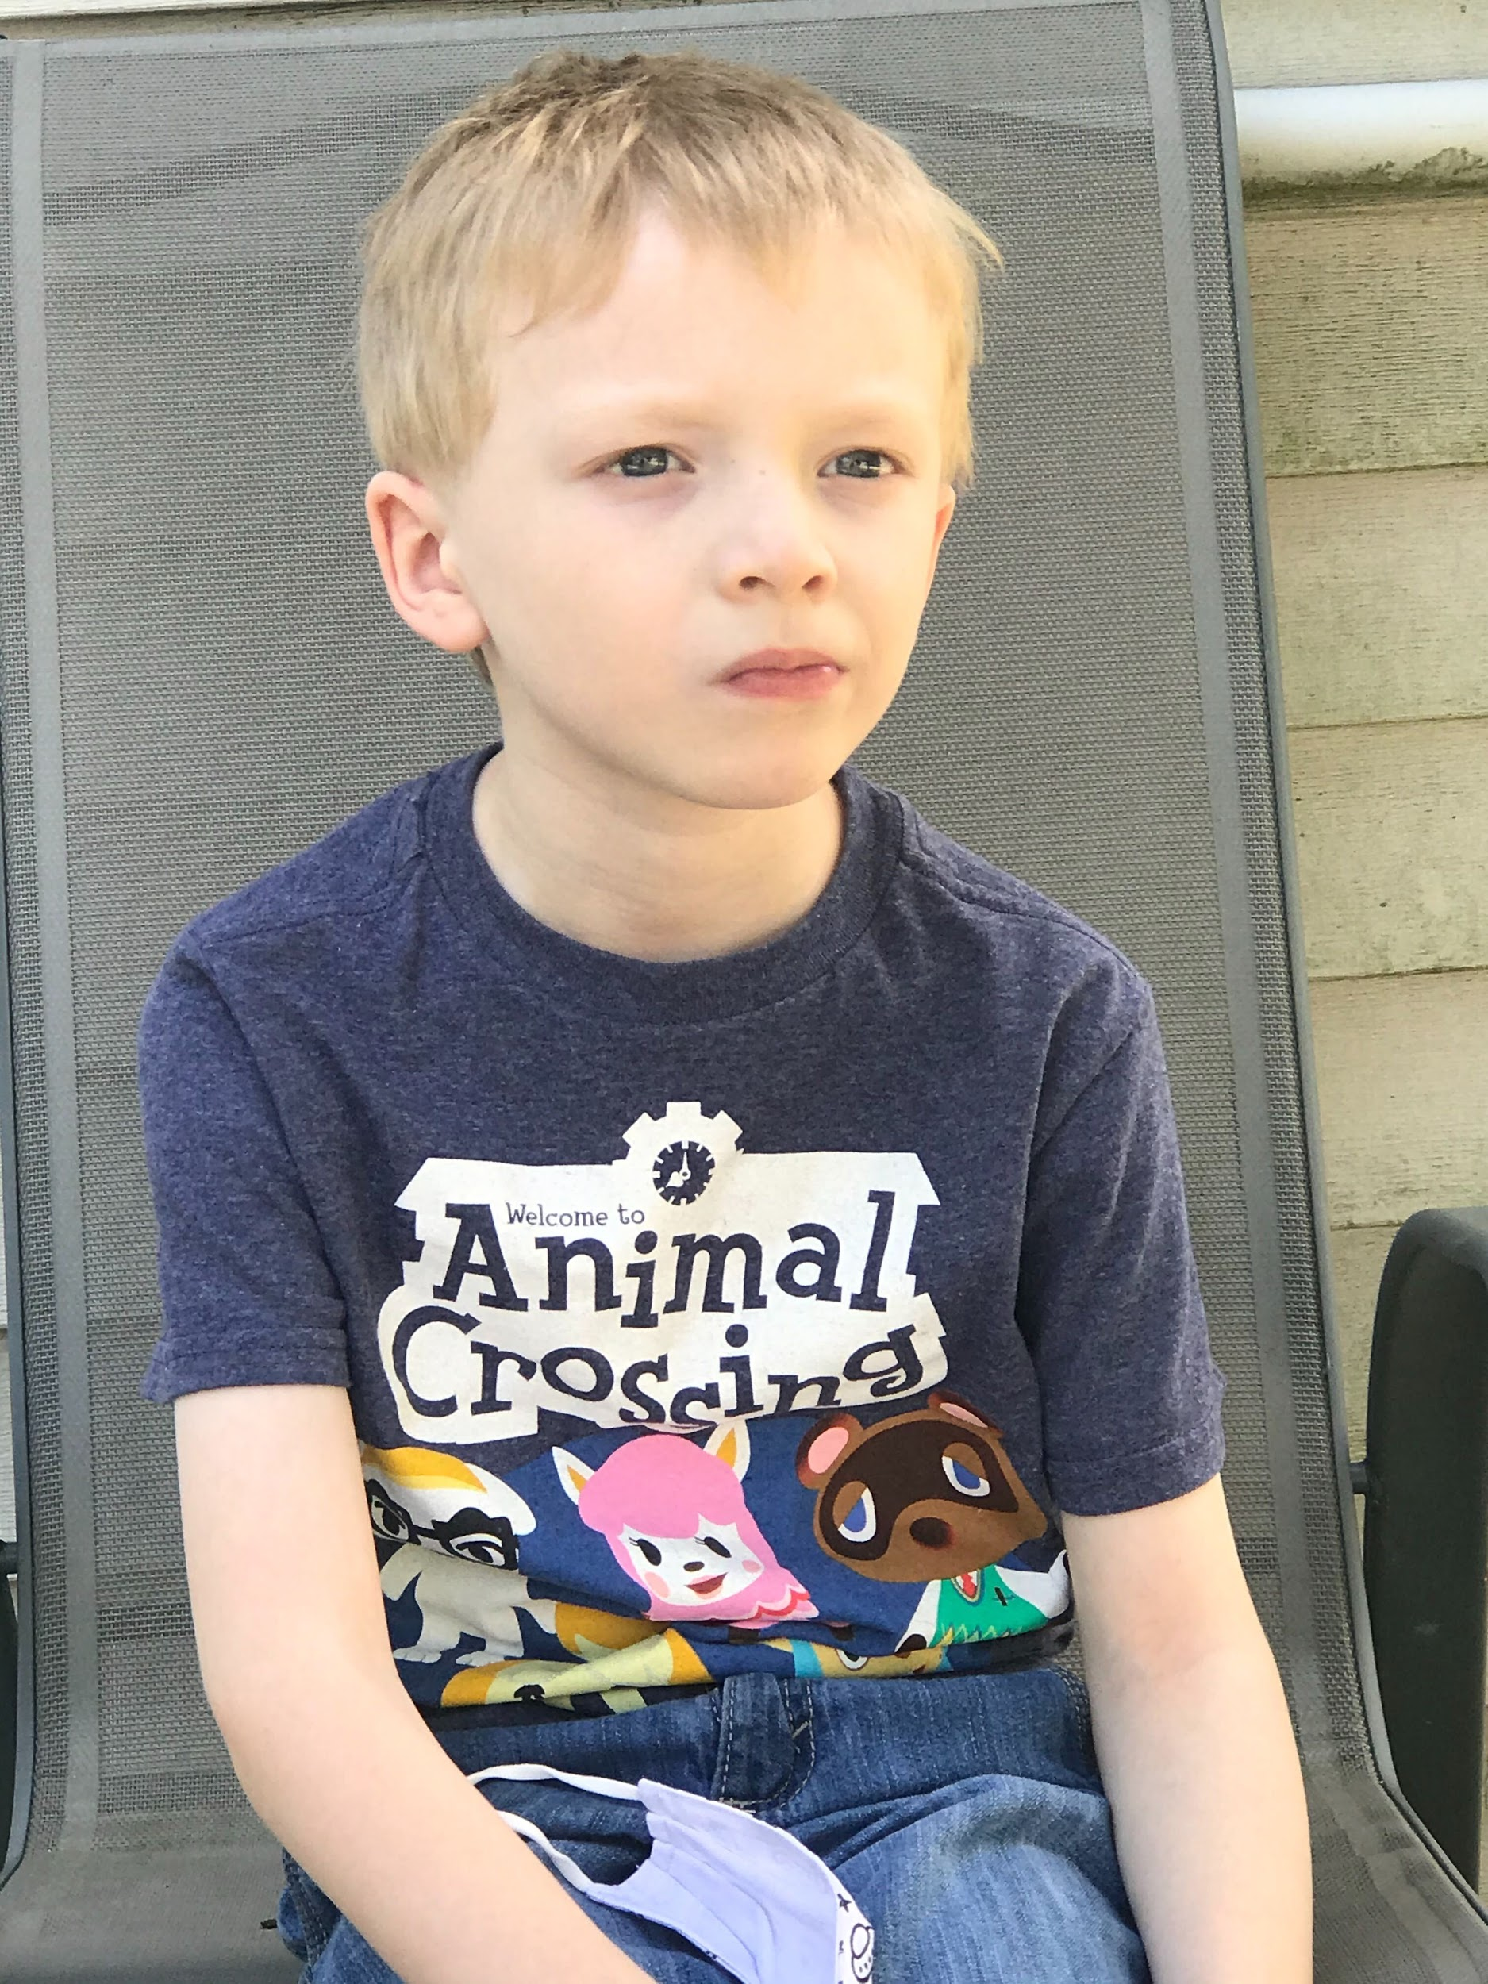

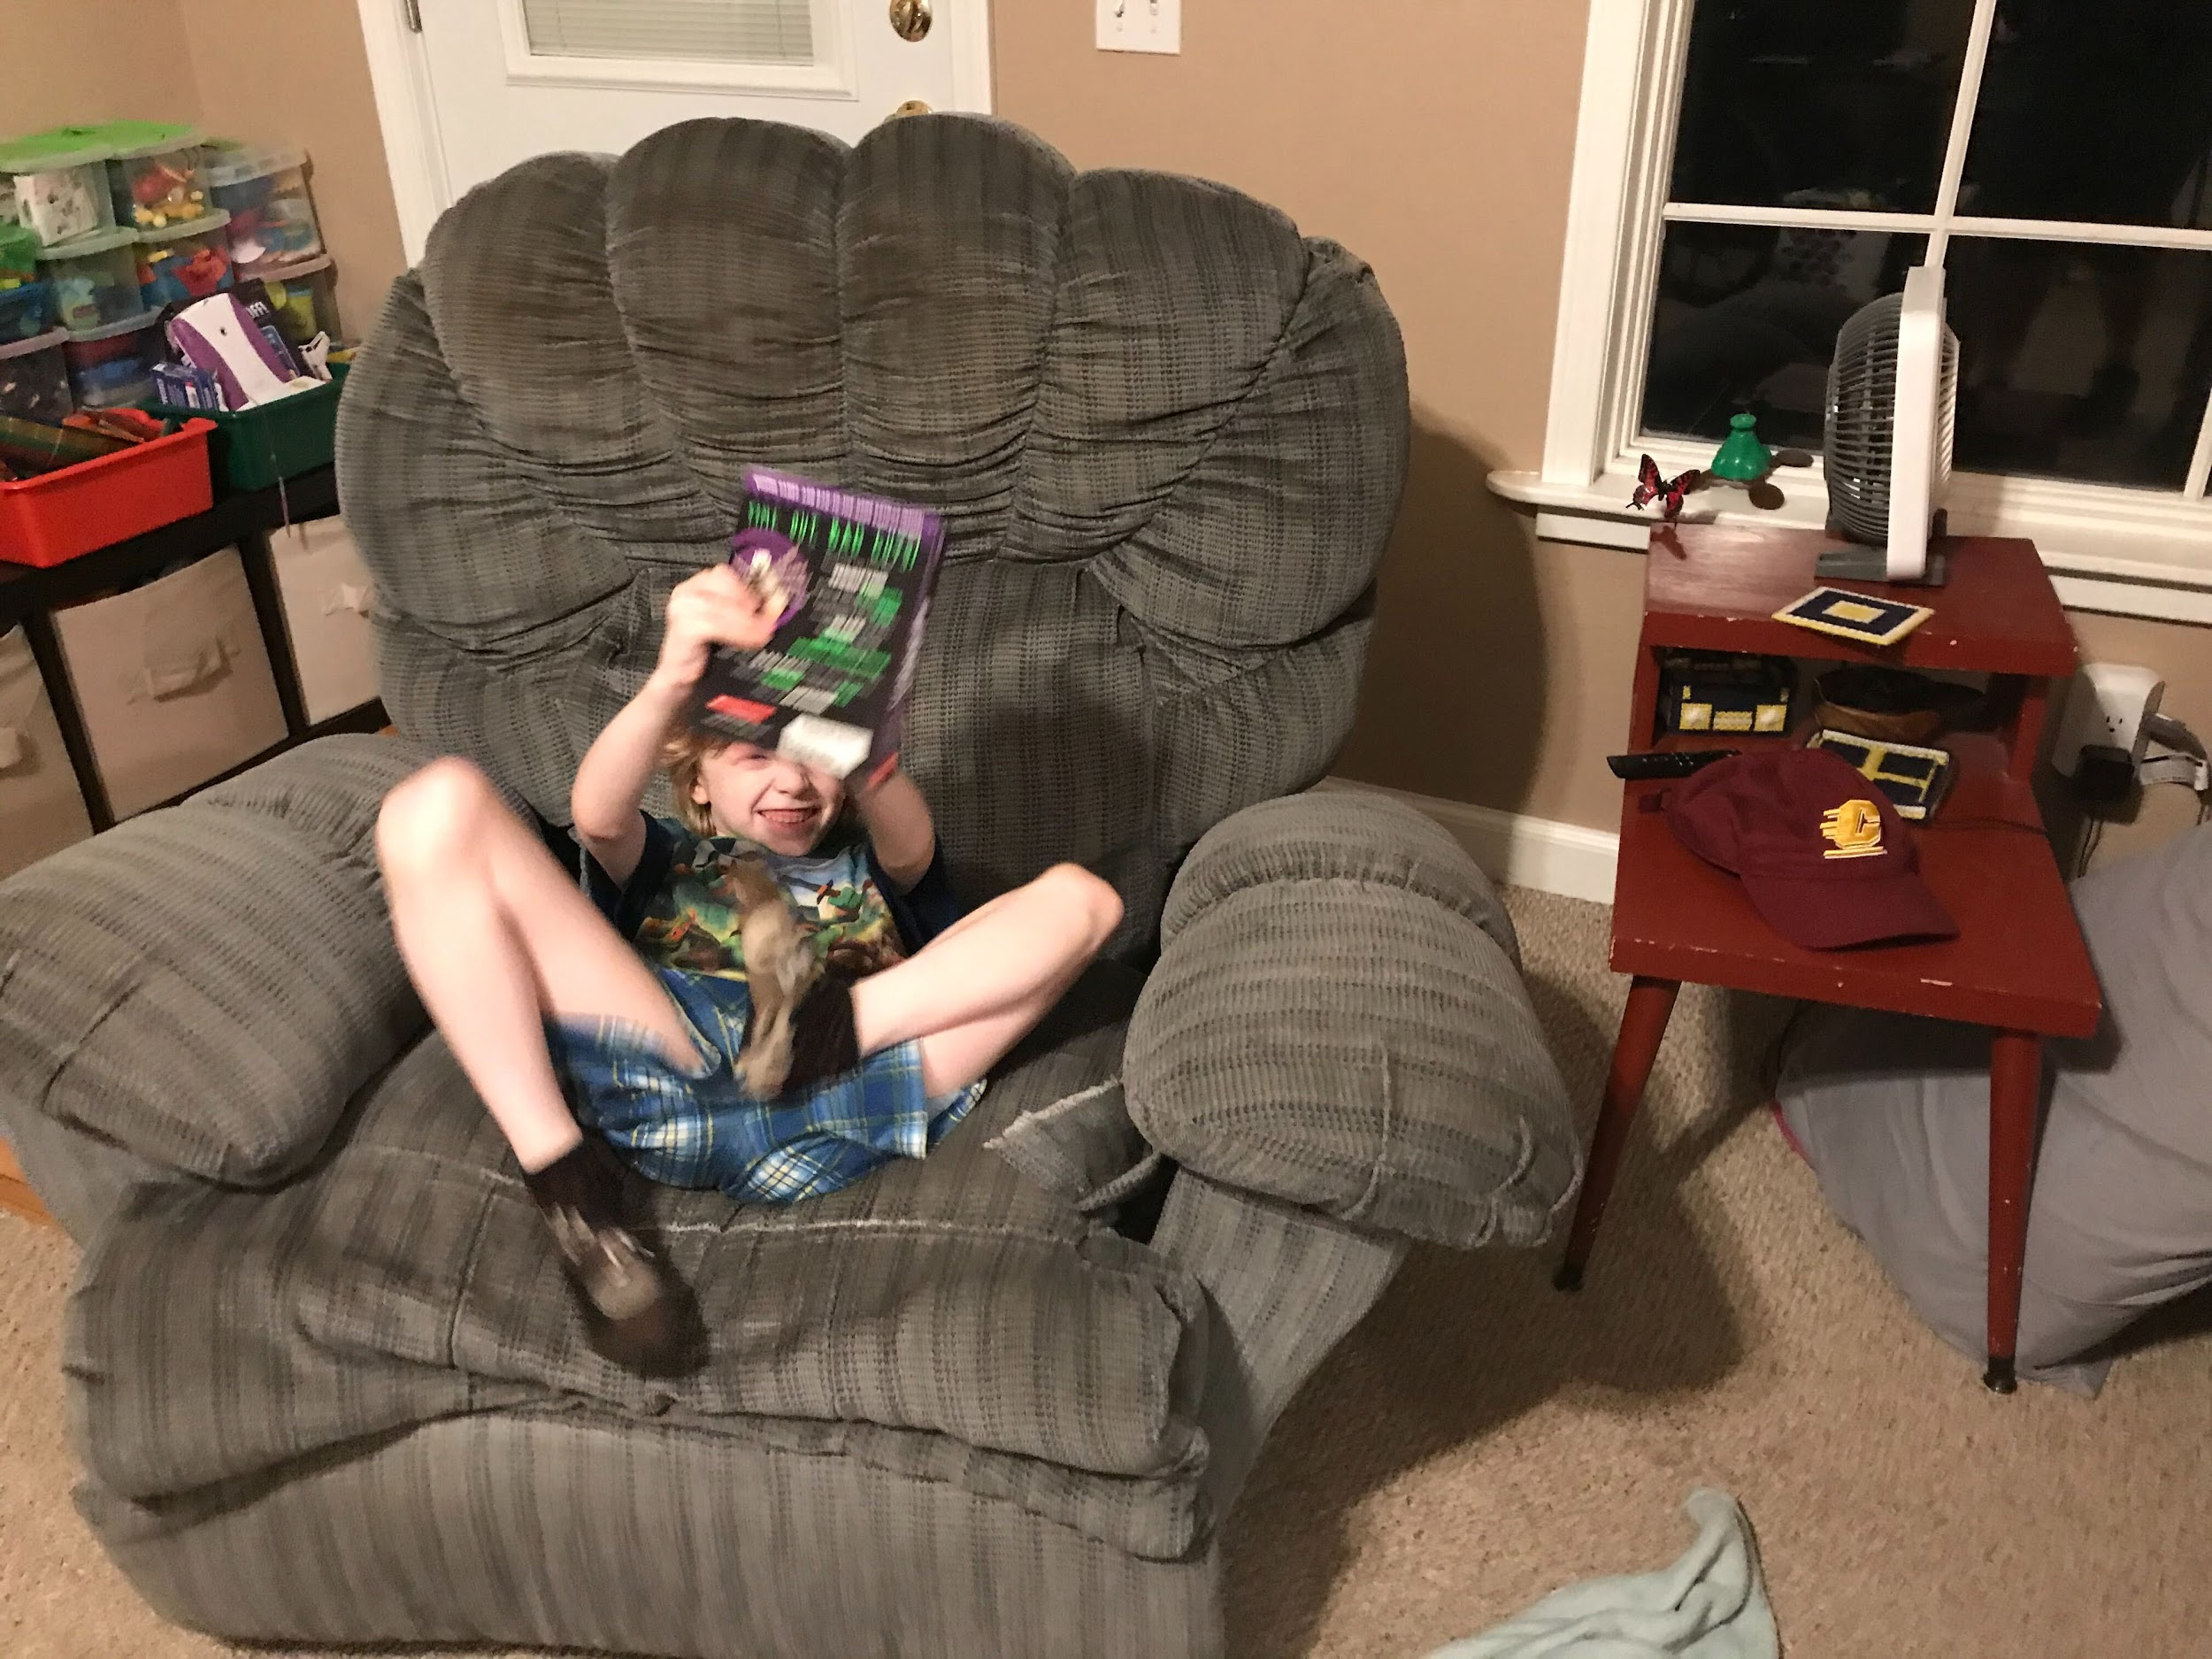

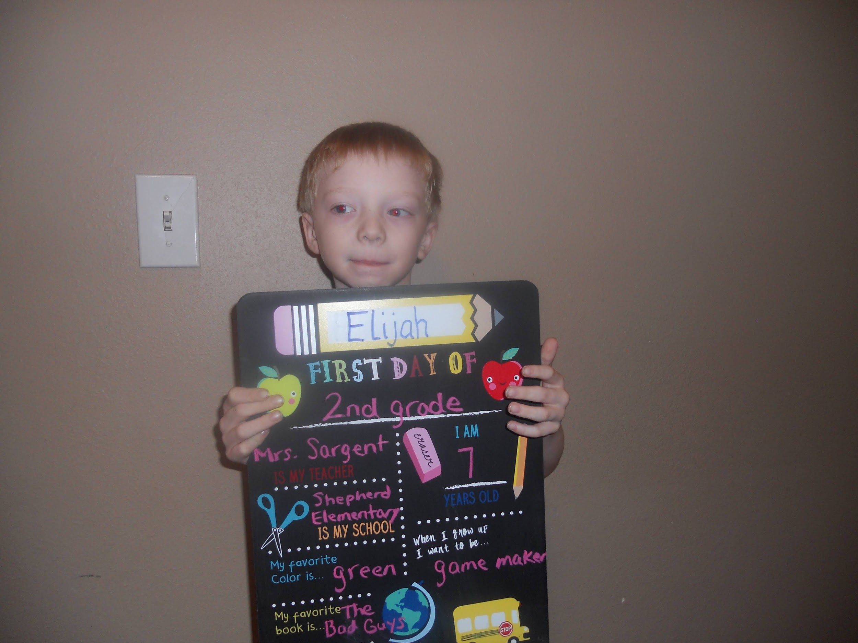

Elijah, who started the 2nd grade, is attending school in person four days a week. The kids need to wear masks the entire time that they are in school. The process for picking up your student at the end of the day has changed quite a bit, something that I experienced first-hand on Monday. Last year, we would retrieve our child from the cafeteria, but this year the procedure is to signal our readiness via an app, and then pick up your kid from the curb. Basically, it is like they took the concept of curbside pickup which has been introduced by stores like Walmart or Target and applied it towards school. The only problem is that Elijah still isn’t great about buckling himself into his car seat, so I couldn’t just take off as soon as he was in the car.

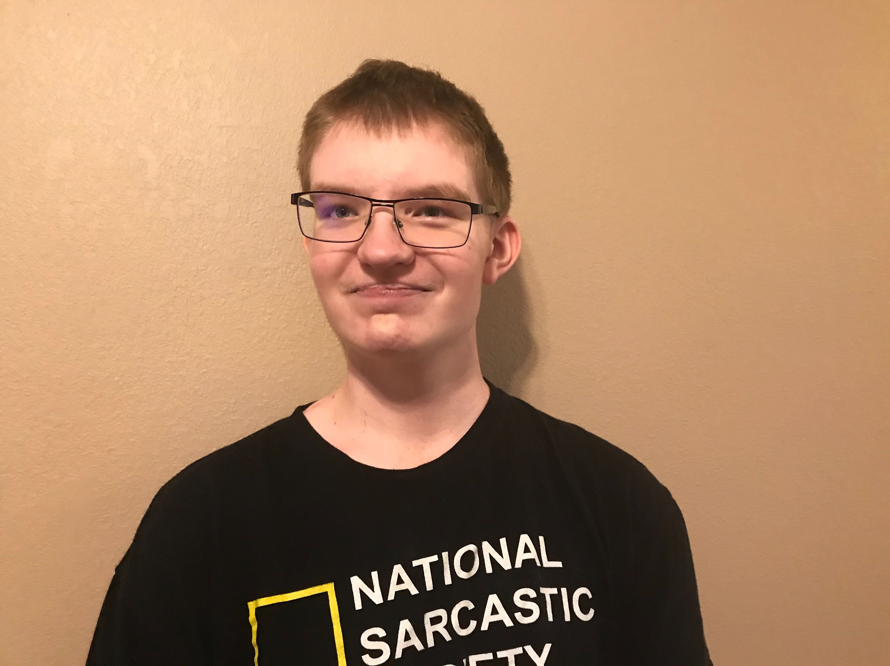

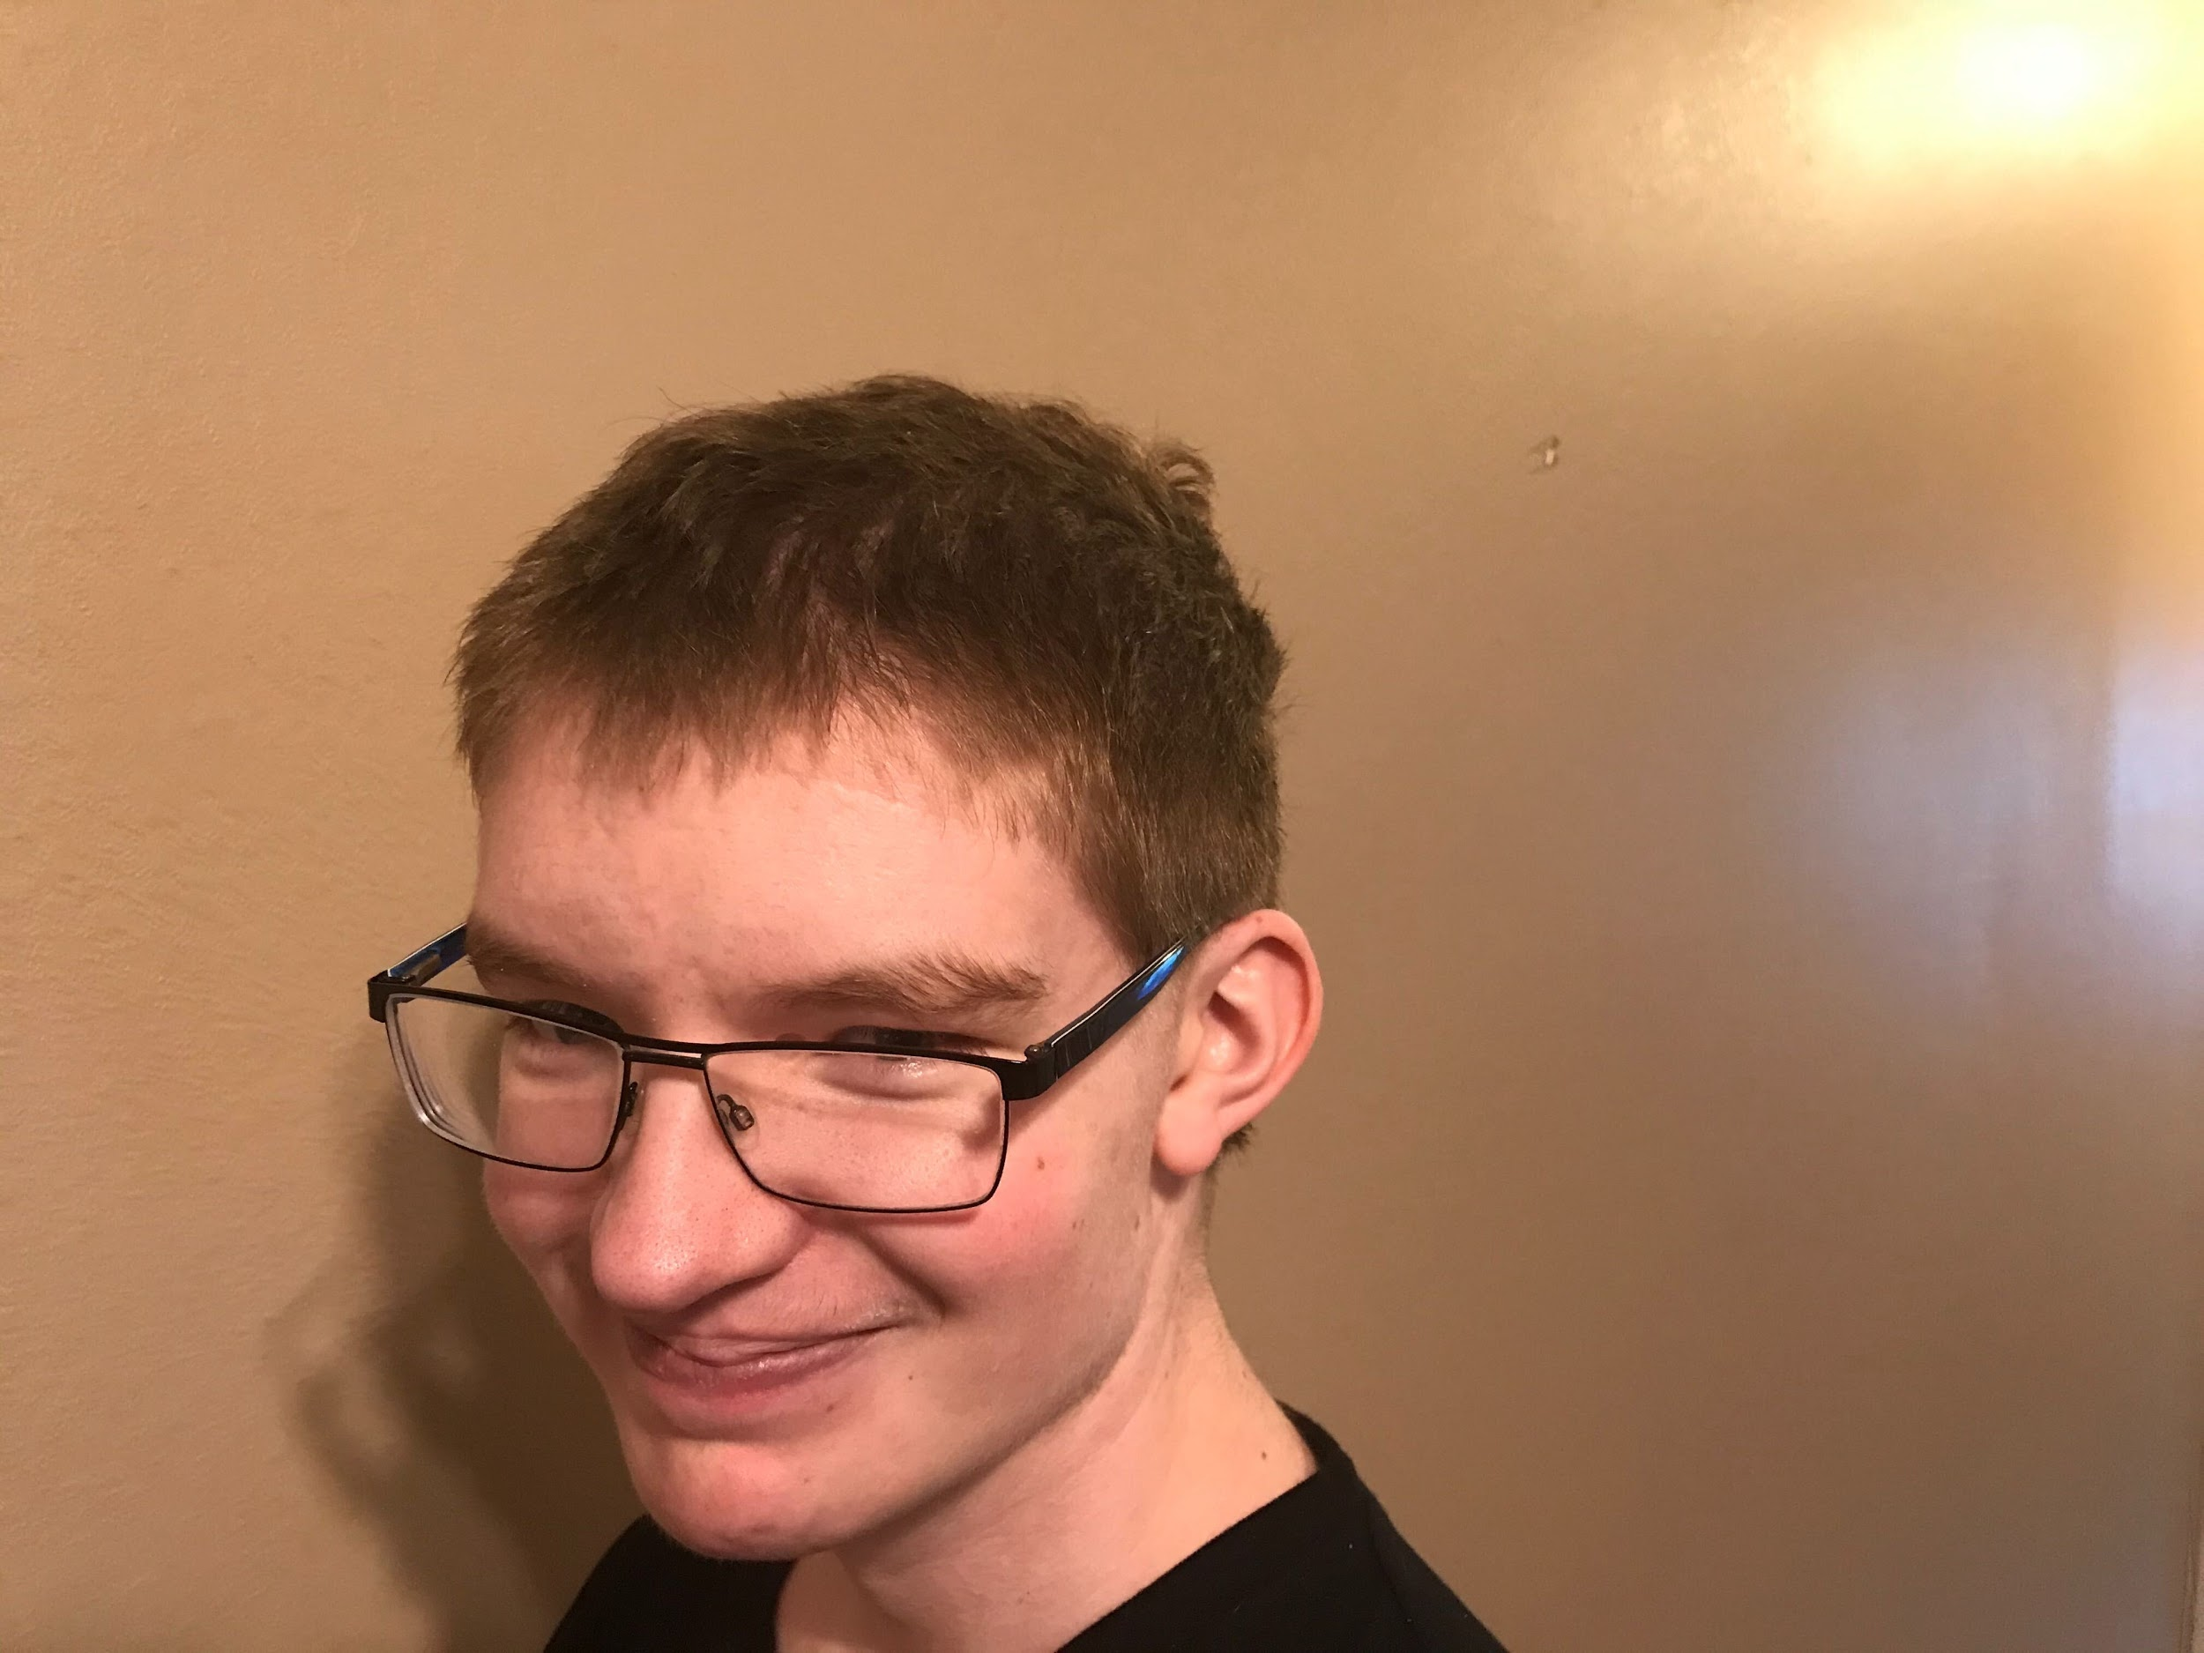

Josh is taking a math and Zoology class virtually this year. I think that he was a little overwhelmed around the middle of the day on Monday, but he’s been able to keep up with the assignments. This year, Shepherd High School switched to a new application called Zoology for communications and assignments. This has been interesting for me, because Schoology was one of the many education applications that I dug into while I was researching effective user interfaces for students. Back then, it was all theoretical, but now I am seeing it put actual use and participating as a parent.

Students at Shepherd Public Schools are home on Wednesdays so that the buildings can be deep cleaned. So, this means that Elijah will be home on Wednesday, but homework packets are being sent home for 2nd graders. Josh has video calls with his teachers on Wednesdays.

Josh started a new cancer treatment last Friday. This marked a way from the Avastin infusions, and is the first time that we’ve administered a drug to him since his chemotherapy ended in December. However, his chemotherapy was one week on for a month, and then the rest of the weeks off, so there was a bit of a breather. The drugs he is on now he has to take at exactly the same time every day. He also needs to have blood drawn, much as he routinely did for his chemotherapy, but the time we have to go to a hospital which is affiliated with Spectrum because of the nature of the tests that need to be done. It was nice when we could just drive over to the hospital in Mt. Pleasant, but right now that’s a thing of the past. Fortunately, there is such a hospital in Lakeview which is less than an hour away, so we’re not required to drive to Grand Rapids. The blood tests measure how much of the drug remain in his body, so the blood must be drawn at exactly 10 a.m. Josh has blood tests every Tuesday.

The blood tests will help tell Josh’s doctors two things. One, it will help detect any health concerns related to the anti-cancer drugs. Second, they are measuring the “trough levels.” If things look good, the dosage for one of the pills Josh is taking will be increased. So, he is taking it twice a day.

The first day he started the new drugs, he threw up quite a bit and things were looking a little rough. But, since then his body seems to be tolerating the medication. We hope that this new approach will be a turning point in his overall treatment.

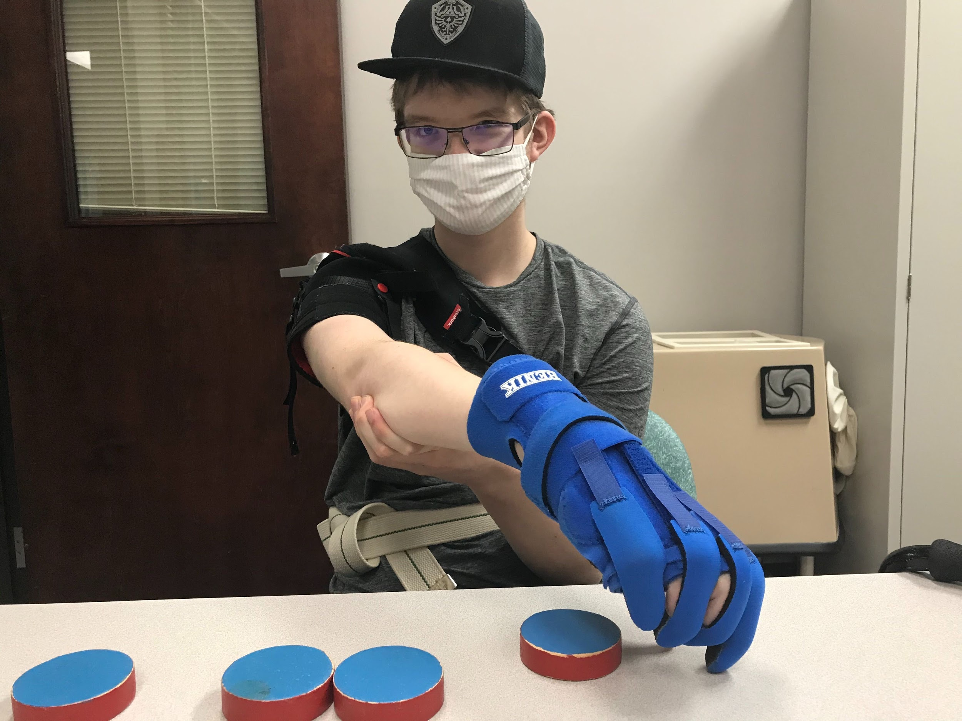

Josh has also been making big strides in his physical therapy. He was recently fitted for two new hand braces which help to stretch his fingers out when he’s sleeping, and when he is practicing picking up objects. I have enjoyed seeing the new focus which is being put on his hand and his arm, and the success he has been having with completing tasks like putting on his hat or picking up cones with his right hand. These are tasks we all take for granted, but for him they are big achievements.

For me, the start of a new school year often makes me feel anxious. I’m not sure why, given that I haven’t personally been in school for twenty-five years. But, it does sometimes feel like we go to school with our kids, as they bring home work they need help with or we attend meetings with teachers. September also a reminder of the passage of time, indicated by the start of a new school year, but also significant because I’m a year older on the 24th. Actually, Kayla, Theresa, and I are all a year older. It is also the start of Fall weather, bringing us closer to winter.

This September is particularly poignant because it will mark the one year anniversary of the day when I found out that I was being laid off from EduGuide. So, we are nearly to the point where I’ve been unemployed for a year. This isn’t the longest that I’ve been unemployed, but I’d like to believe that I’ve put everything I have into getting a new position. Initially, I felt confident that I would “slide” into a new position easily, but then as many of my applications returned no responses, and the responses that did come back were “no thank yous,” I started to get a little more worried. The job interviews seemed to slow down around the holidays, something I expected, but then seemed to pick up again around the end of January and February. It seemed that things were warming up the closer we got to Spring, but then of course COVID19 hit the US, and the state shut down around March. I know that there were some employers who had to rethink their entire hiring process so that it fit within the social distancing requirements. Long story short, it is difficult to hold meetings and schmooze with candidates during a pandemic.

Job hunts have always been a challenge for me, so I’ve been fortunate to have land the jobs that I’ve had. However, it seems that the stakes are far bigger now than they ever were the other times that I was unemployed. A job means food on the table, coverage for Josh, paying our bills, and gas for our cars. Another wrinkle is that I need a job that allows me to stay at home, or else there is nobody to watch after Josh while he’s home, or Elijah when he’s home on Wednesdays. I know that this is a concern that many parents must have when they sign their kids up for virtual classes.

There are a lot of uncertainties in our life right now. These include my job hunt, the election, pandemic, and Josh’s cancer treatment. The outcome of many of these decisions or issues will have huge ramifications for my family. The only thing I have control over is my own employment, and I hope to solve that issue soon. Once I have a full time job again, our other problems will feel a little smaller.